Baby Gift bags.

These bags are for the unit to put information in when the babies are well enough to leave the unit. It can then be used as a keepsake bag for babies first items. Hospital tags, first bonnet etc.

I have tried a few different methods of stitching these little bags and I have found that the one below is the least fiddly and the quickest to make with a really nice drawstring finish. You could use your own pattern if you would like to.
Please keep these made in pretty quilting/dress type fabrics but they do not necessarily need to be in 100% cotton as they are a keepsake bag and will not be used by the baby!! They can be made of one piece of fabric or joined at the side (see below), appliqued bags are fine. You could also use an overlocker if you prefer and then not have to use the double fold on the sides.

Finished size 12” x 8” This is about the same size as a A4 piece of paper.

Requirements: -
Fabric – 13 ½” x 18”
Ribbon 24”
Top edge

13 ½”

18”
Method.

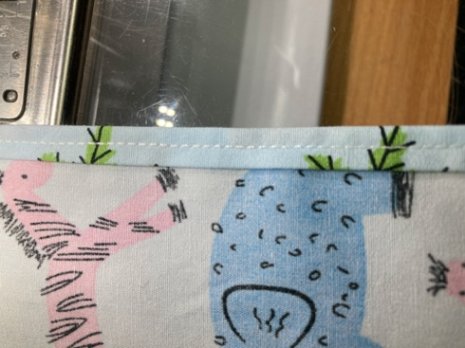
Press both short (side) edges over twice with a scant ¼” and stitch the fold in the centre to neaten. This neatens the seams at the drawstring opening.
To make the casing.

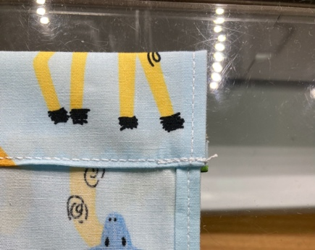
Fold over one long (top) edge ¼” and then a further 1” and press.
Stitch along the bottom fold to make the ribbon casing.

To finish the bag

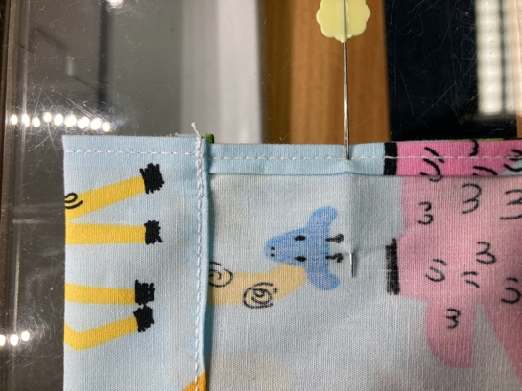
With right sides together, fold the fabric in half, matching the top edges and sides. Starting 2’ down from the top of the bag, stitch down the side of the bag and along the bottom edge.
From where the pin is.

Using a safety pin, thread the ribbon through the casing and anchor the ribbon at the opposite side on the fold with a few stitches. Trimming the ends of the ribbon on the diagonal makes a nice finish.

