84
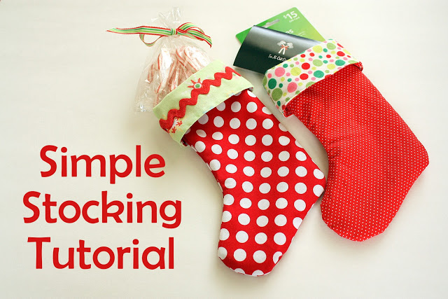

This is a super EASY method for making lined stockings. Most of the text and all of the images come from Diary of a Quilt by Amy Smart and she has given permission for me to use the images and instructions for this project.
The great thing about this method is that you can use any size and shaped stocking pattern or template and make stockings as big as you want by following the same, easy process. They can be small enough for decoration or large enough to hold small gifts.
So start by drawing out your template onto cardboard or designing one of your own. Fabric requirements need to be enough fabric to cut two stocking shapes from two different fabrics. For this size stocking you will need a 13″ x 20″ piece of fabric for front and another the same for the back outside pieces, and another two pieces 13″ x 20″ for front and back lining pieces.
I used applique for the front of my stockings and a plain piece of fabric for the back. As an alternative you could do some patchwork for the front and you could also use calico for the back or any plain fabric, or even a baby type fabric. If only using two fabrics, one for outer and one for inner, follow the instructions below.

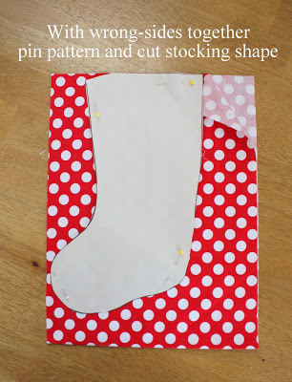
With wrong sides together, cut TWO stocking shapes of both your outside fabric and your cuff/liner fabric. I put wadding behind the front of the stocking to give it a little more ‘body’. IMPORTANT: make sure your toe faces both directions for each fabric. (This is why matching wrong sides together will help you get pieces facing both directions.)

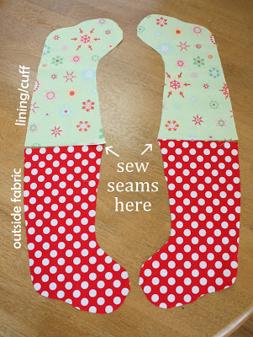
Now pair up one outside fabric with one lining/cuff fabric with the toes pointing the same direction like this. (See picture above.) Match the outside fabric and lining fabric from each set right sides together and sew a 1/4″ seam along the top of the two pieces. Open pieces up and press seam open. Repeat for back side.
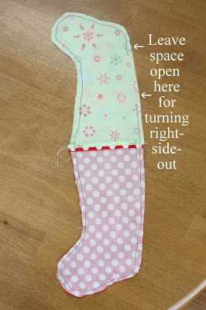
Now match front and back pieced units right sides together with outside fabrics matched up and lining fabrics matched up. Center seams should match up too. Pin to hold two sides together. Leaving a space in the lining fabric for turning right side out, sew all the way around the outside edge of the stocking pieces.
I sewed a 1/4″ seam allowance around the outside [polka-dot fabric] and 3/8″ seam allowance around the green lining fabric, except the space left open for turning. This will help remove some of the bulk of the lining fabric. But if that’s too confusing, just sew 1/4″ for all.
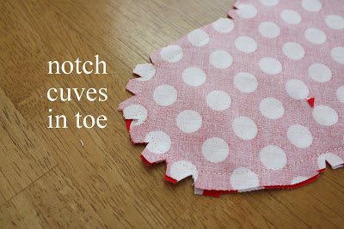
Before you turn everything right-side out, cut notches in the curves – especially the toe. This will help the toe look nicer when finished. Be careful not to clip through the seam.
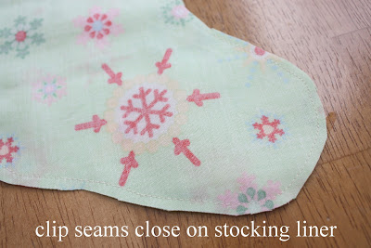
On the liner side, clip the fabric close to the seam.
This will also help remove some bulk on the lining.
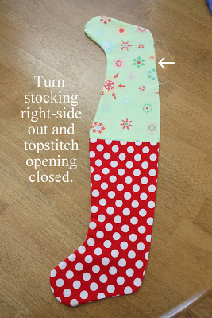
Now pull everything right-side out. Carefully shape the outside part until the curves look good and press. Tuck the open ends into the stocking and topstitch the opening closed.
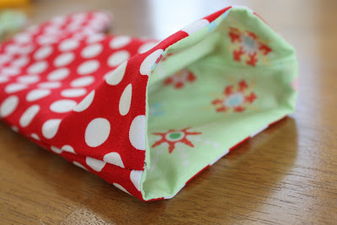
Now carefully tuck the lining inside the stocking.
Optional: Top stitch around the top edge for a more finished look.
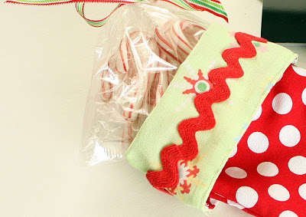
You could fold the cuff down but I didn’t
Optional: add decorative trim if you want.
And you’re done! I suggest making a practice stocking just to see how it comes together and I guarantee each stocking you make after that will get faster and easier. You could easily make a bunch in one afternoon.
You can find the original instructions for this method here https://www.diaryofaquilter.com/2010/12/easy-stocking-tutorial-today.html
I haven’t tried, but you could use fleece for a soft finish.
Thank you for joining in with this special project.

